41.31: a)
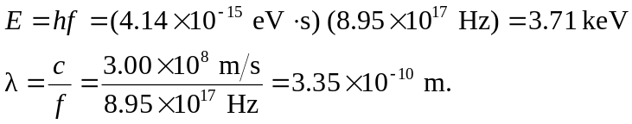
b) Z = 27:
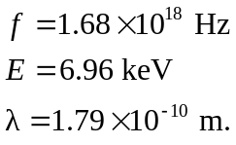
c)

